## MINI PROJECT – I SYNOPSIS

## on

**“Online PVR ticket Booking System”**



Department of Computer Science & Application

## Institute of Engineering & Technology

SUBMITTED TO: - SUBMITTED BY: -

Mr. Manoj Varshney Kartikey Srivastava

(Asst. Professor) (201500329)

# Acknowledgement

It gives me a great sense of pleasure to present the synopsis of the B.Tech mini project undertaken during B.Tech III Year. This project is going to be an acknowledgement to the inspiration, drive and technical assistance will be contributed to it by many individuals. I owe special debt of gratitude to Mr. Manoj Varshney, Technical Trainer , for providing me with an encouraging platform to develop this project, which thus helped me in shaping my abilities towards a constructive goal and for his constant support and guidance to our work.

His sincerity, thoroughness and perseverance has been a constant source of inspiration for me. I believe that he will shower me with all his extensively experienced ideas and insightful comments at different stages of the project & also taught me about the latest industry-oriented technologies. I also do not like miss the opportunity to acknowledge the contribution of all faculty members of the department for their kind guidance and co-operation.

**By:**

Kartikey Srivastava

(201500329)

## ABSTRACT

The aim of developing PVR Booking System is to replace the traditional way of booking with computerized system. Another important reason for developing this project is to prepare order summary reports quickly and in correct format at any point of time when required.

PVR Booking System has a very lot of scope. This Python Based project can be used by any PVR Mall for customers for keeping their PVR booking records. This project is easy, fast, and accurate. It requires less disk space. PVR Booking System uses Python as backend so there is not any chance of data loss or data security.

It is very useful in our day to day life, by which you can easily book your tickets from anywhere.

**Table of Contents**

Abstract Declaration

Acknowledgment

1. Introduction
   1. Objective
   2. Motivation
   3. Problem Statement
2. Software Requirement
   1. Hardware Requirements
   2. Software Requirements
3. Project Description
4. Functionality
5. Working
6. Use Case Diagram
7. Data-Flow Diagram
8. Why do we need this project
9. Hardware and Software Requirements
10. Implementation and Platform Used

# INTRODUCTION

The main objective of this project “**PVR Management System**” is to book tickets online. It provides an alternate and convenient method for a customer to purchase tickets. The system is automatic in nature. Once the data is fed into the database, the staff need not do anything and the entire order is processed by the system. This project also offers the option of refund to the customers.

The System allows the customers to book tickets from anywhere. This could bring in more profit for the theatres.

The statistical records about the booking process are also provided .

**The objective of this project**

The main objective of this project’s PVR Management system is to manage the details of Movies, Tickets, Booking Customers, Seats, and Show timing. It manages all the information about Movie, Cinema Hall, Show Timing, and Movie. The project is a totally built-in administrative end.

The purpose of this project is to build an program to reduce the manual work of managing movie tickets, Cinema Halls, and Booking Customers. It tracks all the details about the booking Customers, Seats, and show timing. It also can reduce the efficiency of the employee and customer can easily get there tickets online without any problem facing.

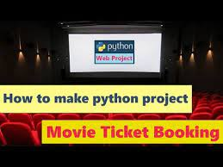

Movie Ticket Booking System

**The functionality of the project**

It is showing the Seat Availability, Movie Timing, and Booking Status PVR Management System also manages the Cinema Hall details online seat details.

It tracks all the information about tickets to Cinema Hall.

Manages the Information On tickets.

Shows the information and description of the Movie Booking Customer.

To increase the efficiency of managing the Movie Ticket.

It also increases the profit of the Theatre and it can also display the promotion of the movie.

Customer can customize their seats according to their choices and they can share their reviews and the customer can easily book the tickets of his choice and of his timing.

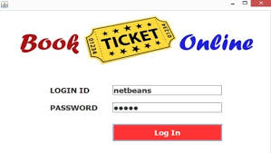

**Working of the project**

1. First user enters the no of the row and the seat he/she wants to choose.
2. After selecting the above two choices then if a customer can see the seat availability chart
3. Manager or any authorized administrator can see the no of tickets booked, and current income total income.
4. As the customer enters for buying a ticket, he/she has to enter
   * 1. No the column and row want to book the seat
     2. No tickets want to buy
     3. Price of the ticket will appear

5. customer has to give the confirmation “would you like to book

ticket “yes”/”no”

6. If the customer enters “Yes” it will ask for

* + - 1. Enter your name:
      2. Enter your gender
      3. Enter your age
      4. Enter your mobile no (customer has to enter the correct mobile no otherwise it displays the message “invalid mobile no.”

7. Once all have done you have successfully booked the ticket

8. If an administration wants to see the booked ticket customer

information

* + 1. Enter the no of rows you want to check
    2. Enter the no of columns you want to check
    3. All the information will be present on the screen
    4. If a seat is empty /or not booked then the “seat is vacant” message will appear

**Use Case Diagram**

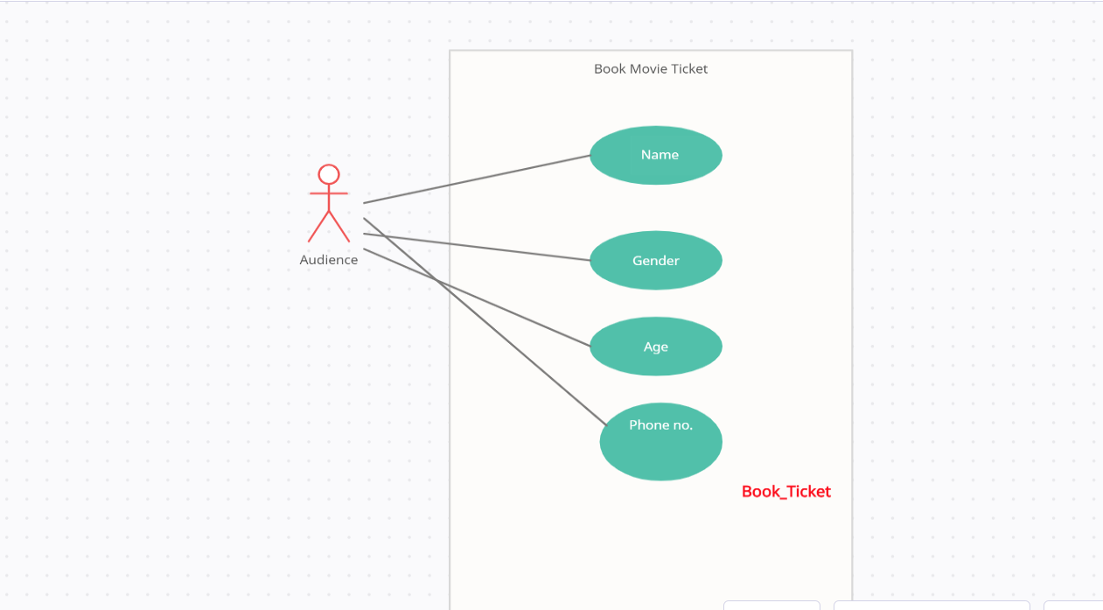

Use case for customer details when booking a ticket

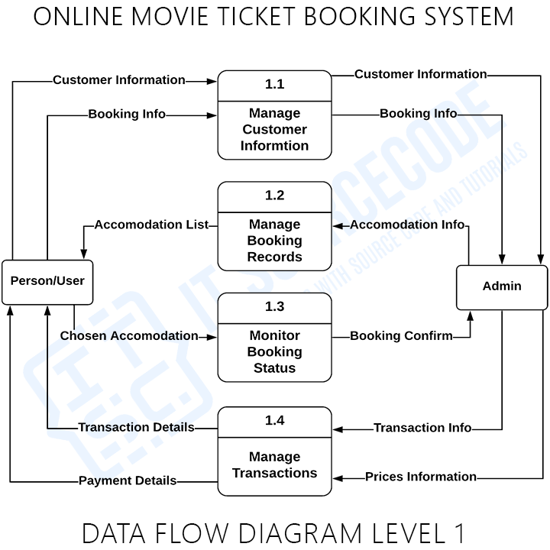**Data- flow- Diagram**

Data Flow Diagram of Level-1

**Why do we need**

Online Cinema Ticket Booking System

Numerous people are constantly flooding movie theatres and cinemas for some entertainment daily. The excitement of these customers can be crushed however by the long lines involved in the manual process of booking and buying tickets. This is why many businesses are opting to invest in digital ways for customers to access their services.

An online movie ticketing system is a digital platform that allows customers to access the services of a business, reserve seats and buy tickets. This platform provides details such as what time a movie will be played, what seats are available, movie previews and so much more.

## 

## SOFTWARE REQUIREMENTS

* Vs Code
* IntelliJ Idea
* PyCharm IDE Platform
* Python Modules

**HARDWARE REQUIREMENTS**

* Internet connectivity:1mb/s Net Connection
* Storage:512 MB Ram
* Window 7,10,11
* Processor: i3 processor-based or further
* Device used: Laptop

## IMPLEMENTATION And PLATFORM USED:

**Python:** Python is **developing computer language and software used for task automation, data analysis, and data visualization**. Since it's relatively easy to learn, Python has been adopted by many non-programmers such as accountants and scientists, for a variety of everyday tasks

**VScode Editor:** Visual Studio Code is a code editor. Like many other code editors, VS Code adopts a common user interface and layout of an explorer on the left, showing all of the files and folders you have access to, and an editor on the right, showing the content of the files you have opened.

VS Code comes with a simple and intuitive layout that maximizes the space provided for the editor while leaving ample room to browse and access the full context of your folder or project. The UI is divided into five areas:

* **Editor** - The main area to edit your files. You can open as many editors as you like side by side vertically and horizontally.

## REFERENCES

**Books:**

### Python Programming – An Introduction to Computer Science by John M

* Python Crash Course by Eric Matthews

## Websites:

* [www.google.com](http://www.google.com/)
* <https://projectworlds.in>
* <https://www.javatpoint.com/python-libraries-for-data-visualization>
* <https://www.geeksforgeeks.org/platform-module-in-python/>

## Faculty Guidelines:

Mr. Manoj Varshney (Asst. Professor in GLA University)

## GitHub Repository link:









